

**CSE423: Computer Graphics**

**Spring 2023**

**Lab** **Assignment 1**

**Important Instructions for the Assignment:**

* Before starting this assignment, please ensure that you have installed the mentioned **OpenGL libraries** in your System.
* The skeleton code is provided for completing the tasks or you can design your own.
* For submission, paste your source code along with the screenshots of the output in a single doc file and submit it in the classroom.
* You have to submit it in the classroom. Please follow the submission instructions carefully. Failure to follow will be subject to 20% to 50% marks penalty.
* The deadline for submission is to be strictly maintained. **Late submission will not be accepted.**
* **You must attend the lab viva for each assignment otherwise you won’t get any lab marks for that assignment.**
* **Any form of plagiarism will automatically cancel your assignment.** Please refrain from such activities.

**Task 1: Drawing Pixels**

You are supposed to draw **50 pixels** (coordinate points). For this, you need to generate **100 random** values (50 x - coordinates and 50 y - coordinates). You do not need to join any pixels for this task.

**Task 2: House Building**

You have to draw a **House** using the base primitives: points, lines, or triangles. You can use **ONLY** ***GL_POINTS***, ***GL_LINES*** or ***GL_TRIANGLES*** for designing this house. A diagram has been provided as an example. **You can modify the house design to your liking.**

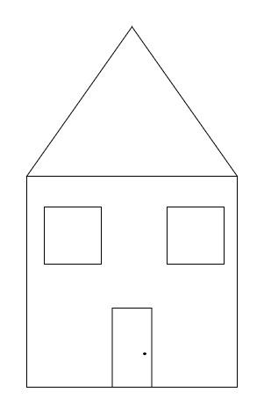

**Task 3: Student ID**

Show your **Student ID** where each digit should be of **different colors.**